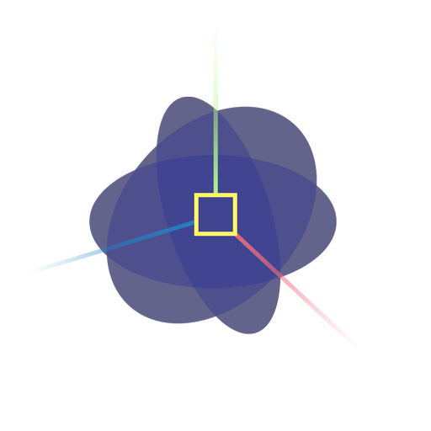

Crysta Frost

Technical Artist

www.crystafrost.com

crysta.frost@gmail.com

Richmond, CA

**Experience**

**Visual Concepts Entertainment**

June 2017-Present

Technical Artist

www.vcentertainment.com

Artist tool development, pipeline and render farm management, photo-realistic character and clothing rigging and real-time dynamics.

**Projects**

NBA 2K18

NBA 2K19

NBA 2K20

NBA 2K21

**Unity Technologies**

January 2017 - June 2017

Production Associate, EDU

www.unity3d.com

Professional Certification project planning and management, diversity and inclusion initiatives, mentorship, rigging and animation, recruiting.

**Modsy**

May 2016 - January 2017

3D Intern

San Francisco, CA

415.340.1924 - www.modsy.com

Project planning and management, writing tools, organizing meetings, pipeline optimization.

**Education**

**BFA in Game Development** (2016)

Valedictorian

Specializing in Technical Art

Academy of Art University

San Francisco, CA

**AA in Fine Arts** (2012)

Summa Cum Laude

Specializing in Drawing and Oil Painting

Northern Virginia Community College

Sterling, VA

**Software & Skills**

Autodesk Maya

Python

Perforce (P4v)

Shotgun

Deadline

Adobe Photoshop

Unity

Unreal

C#

**Awards**

Academy of Art Spring Show 2016

**Languages**

English - primary

German - Intermediate speaking/writing